GREENWICH FLYING SQUADRON
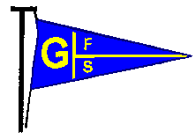

P.O. Box 5092, GREENWICH NSW 2065

Clubhouse: Bay Street Wharf, GREENWICH

Phone and Fax: 9436 1901

www.gfs.org.au

Sailing Instructions – Keelboats
2019 – 2020 Sailing Season

Twilight Series
Saturday Series
Mick York Series
Saturday Down Harbour Series

DIVISION START FLAGS

Start Flag
Twilight Series Divisions | Blue | Green | White | Orange (Red) | Gold | Black
Saturday Mixed Divisions | Division 1 | Division 2 |  | Not Used | Not Used | Not Used
Down Harbour Series Divisions | Blue (Division 1) | Not Used | White (Division 2) | Red (Division 3) | Not Used | Not Used

GFS RACE SIGNALS

The meanings of visual and sound signals used by GFS are stated below.

An arrow pointing up or down (↑ ↓) means that a visual signal is displayed or removed.

A dot (•) means a sound, a long dash (—) means a long sound, * means no sound.

GFS Sailing Instruction | Code Flags and Pennants | Appearance | Meaning | Possible sound signal
8 | Q |  | Start is from the club launch | *
11 | I or P |  | Preparatory signal – Rule 30.1 applies | 
12 | AP |  | Delayed start | 
13 | X |  | Individual recall | 
13 | First substitute |  | General recall | 
14 | S |  | Shortened course | 
15 | N and AP |    | Racing cancelled | 
16 | N above A |  | Racing abandoned
20 |  |  | Finish Line | *
22 | Red Flag  Or  B |  | Protest flag | Must hail “protest”

Definition: The “Club” means Greenwich Flying Squadron Inc. (GFS), its appointed officers and committees.

1. Eligibility to Race.

                - a. All races are open to yachts on the register of a recognised club in terms of Part 6 of the Racing Rules
of Sailing. A member of the recognized club or GFS member must be on board during all races.

b. All yachts competing in GFS races must have current marine insurance which includes racing cover appropriate to the event. Written Proof of Insurance (POI) must be supplied and to do this a certificate of currency from the insurer showing either comprehensive insurance with racing cover or third party property insurance with racing cover is required listing a minimum of $10,000,000 third party liability.
If the policy is changed or renewed during the season it is the owner’s responsibility to lodge a new Proof of Insurance with the Club prior to racing in the first event after the expiry of the old policy.

c. All yachts competing in GFS races are required to have lodged a current season audited Special Regulations Equipment Compliance Form to a minimum YA Special Regulations: Part 1 – Category 7 – Short races in sheltered waters, in daylight hours and with effective rescue capability, with the Club or hold and produce a current audited Special Regulations Equipment Compliance Form from another club. RRS Rule 78.2 will apply to a yacht unable to deliver this form by the required time.

d. A yacht competing in the Saturday, Down Harbour, Twilight and Winter Series must have a minimum
of two persons on board (skipper and one crew member).

e. The Club reserves the right to reject any entry without stating the reason at any time up to an event’s
  - preparatory signal (RRS Rule 76) or, similarly, suspend any entry.

f. Casual entries may be accepted by the race committee. Proof of Insurance, Yachting Australia membership and Current Safety Audit must be provided. A race fee applies.

g. Any yacht not complying with the relevant conditions above is ineligible to race and will not be awarded
            - points and will be considered to be a non-starter.

2. Indemnity.
All those taking part in any Club events do so at their own risk and responsibility. Participants are also advised that although the Club is covered by third party liability insurance, this cover DOES NOT extend to participants racing. Participants must make their own private insurance arrangements (see 1(a) above). The Club is not responsible for the seaworthiness of a yacht whose entry is accepted or for the sufficiency or adequacy of its equipment. The Club is NOT responsible for damage caused during, or, as a result of, participating in club events. The Club reserves the right to refuse any entry.
Attention is drawn to ISAF Fundamental Rule 4, (Decision to Race) which States: “The responsibility for a boat’s decision to participate in a race or to continue racing is hers alone”.
This RISK WARNING is issued by the Club and the NSW Maritime Authority, pursuant to the Civil Liability Act 2002 to all persons wishing to participate in the sailing activities conducted by the Club. Participants are warned that, regardless of the precautions, which might be taken by reasonable and experienced persons, sailing can be a dangerous pursuit and participants are exposed to risk of property damage, physical harm and possible death.
As an indication, these risks may include, but are not limited to:

- The extremes of weather and sea conditions;
- The potential that control of vessels may be lost, resulting in collision with objects and other vessels;
- The sudden movement of the vessel at any time and the possibility that participants may fall or be thrown overboard, resulting in drowning;
- The possibility that participants may be injured by equipment on the vessel;
- The absence of immediate medical care and the likelihood that significant delays may occur before medical care is available;
- Exposure to the elements for extended periods.

The Club expressly and unreservedly indemnifies NSW Roads and Maritime from all liability associated with GFS events.

The Club and NSW Roads and Maritime Services also warn participants that regardless of their best intentions, they may be unable to render assistance to participants who are in distress. Participants are warned to consider the above risks and all other risks before deciding to participate in any sailing event with the Club.

The Club will monitor VHF Channel 72 during GFS races. However, please plan what you and your crew would do in and emergency. Complete the GFS Safety Card and identify suitable evacuation sites for any injured person. See Page 19 for some emergency locations and contact numbers.

Man Overboard – Crew Retrieval.
International safety guidelines state that every vessel must be able to carry out man overboard rescue.
By July 1, 2020, GFS Skippers must be able to demonstrate to the GFS Equipment Audit team that they have
satisfactory equipment on board for the retrieval of a crew member in the water alongside the vessel.

3. Rules.
All references made to the racing rules shall be interpreted as a reference to ‘the current ISAF Racing Rules of Sailing RRS and the prescriptions and the special regulations of the AYF’.
Attention is drawn to ISAF Fundamental Rule 1 (Safety), Rule 2 (Fair Sailing) and Rule 3 (Acceptance
of the Rules). It is expected that all competitors in GFS events adhere to the principles set out in these
rules.

All competitors shall comply with the World Anti-Doping Code, the rules of the World Anti-Doping Agency, and ISAF Regulation 21, Anti-Doping Code. An alleged or actual breach of this rule shall be dealt with under Regulation 21.
It is the responsibility of each skipper to be aware of any changes and addendums made to these rules.
See – www.sailing.org.

All Club races will be sailed under the ISAF rules as stated above, except where modified by these sailing instructions.
Flags and Pennants: in these sailing instructions, Code Flags and Numeral Pennants mentioned shall be those listed on Page 2.
Definitions: shall be described in the Racing Rules of Sailing.

4. Changes to Sailing Instructions.

Changes to these Sailing Instructions will be posted on the Club internet site (www.gfs.org.au) and/or email to club members who have paid racing fees.

5. Schedule of Races.

Races will be held according to the current GFS Season Program.

6. Divisions and Classes.

Yacht divisions and classes are defined by coloured flags which are used as their starting signal. These are
listed in order of starting.

Saturday Down Harbour Twilight

Blue - Division 1 Blue - Division 1 Gold
Green/White - Division 2 White - Division 2 Orange (Red)
Red Division 3 White
Green
Black
Blue

The number of Divisions to be sailed, and the yachts competing in each, will be communicated to members who have paid racing fees prior to the commencement of the relevant series.

7. Marks.
Marks are set at locations shown on the GFS course map. These marks, if buoys, are conical inflatable buoys labelled GFS.
Inflatable cylindrical or tetrahedral buoys may replace the buoys described above. These will be clearly marked GFS.
The marks, if buoys, in Down Harbour courses are yellow cylindrical can (YA) buoys.
All marks are to be rounded to starboard except when denoted by (P) in which case they will be rounded to port.
When Islands are listed as marks in GFS Courses RRS, Rule 19 applies (Continuing Obstruction).
8. Start Line.
i. The Start Line may be set from either the Clubhouse or the Club launch. Code flag ‘Q’ will be flown at the Clubhouse to signify that the start will be from the Club launch.
ii. The Start Line will be set between a Club mark and the flag mast of either the Club launch or the Clubhouse.
iii. If the club mark is missing, when starting from the Clubhouse, the start line will be set between the flag mast at
the Clubhouse and the flag mast on the Sea Scouts shed on the Hunters Hill shore.

iv. When starting, boats must pass between the Clubhouse or launch and the Club mark. If a clearance mark is laid at the Clubhouse end of the start line, boats must pass between the clearance buoy and the Club mark. If laid, the clearance mark does not indicate the position of the start line.
v. Yachts in subsequent starts must remain well away from the vicinity of the start line until the previous Division clears the start line after their starting signal. See SI 11 (b), (c) and (g).
vi. To allow movement of vessels (competitors, ferries and non-competitors) during Twilight race starts a starting box/ exclusion zone will be in place. The box will be bounded by the start buoy and clearance mark laid off the clubhouse and a line approximately 20 metres South from Northwood wharf and a similar distance north of moorings on the Woolwich shore. See SI 11.

9. Courses and Course Signals.
All GFS Courses are defined by numbers and are listed on the GFS Saturday and GFS Twilight Course Sheets at the start of each season. Courses may be revised during the season.
The letter ‘A’ following the course number shall indicate the alternative shortened course. When displayed, boats are to proceed directly to the finish after rounding the mark so designated on the course sheet.
The course to be sailed can be changed by the starter up to the warning signal of each separate Division. This may result in different divisions sailing different courses.

The course to be sailed will be indicated by a course number displayed on a board at the Clubhouse or on the transom of the Club launch.

Course Signals.

Twilight Courses – Clubhouse start
The course number for Orange Division will be displayed on a red board, the course for Green Division, Gold Division, White Division and Blue Division on a white board and the course for Black Division will be on a black board.

Saturday Courses – Launch Start (Code Flag ‘Q’ flown on the clubhouse flag mast)
The course number for Division 1 and Division 2 will be displayed on a red board with white numerals.

Division 1 will always sail the blue (B) course. For Division 2, a Green Flag at the start will indicate the
GREEN (G) course is to be sailed and a White Flag the WHITE (W) course is to be sailed.

Saturday Courses – Clubhouse start.
If Division 1 and 2 sail different courses, the course number for Division 1 will be on a blue board and the Division 2 course will be on a white board.

If both Divisions sail the same course, the course number will be on a red board with white
numerals.

Down Harbour Courses – Clubhouse start
The course number for Division 1 (Blue) will be displayed on a blue board, for Division 2 (White) a white board and Division 3 (Red), a red board.

10. Starting Procedure.

All starts rely on flag movements. Sound signals may or may not occur.

i. Down Harbour Point Score Series – Scratch Start.
PT Down Harbour (1315hrs) |  | Club Pennant raised
 |  | Sound signal
PT + 5 min | Division One class warning signal | Blue Pennant raised
 |  | Sound signal
PT + 6 min | Division One preparatory signal | Code Flag ‘I’ raised
 |  | Sound signal
PT + 9 min | Division One 1 minute signal | Code Flag ‘I’ lowered
 |  | Long Sound signal
PT + 10min | Division One Start signal | Blue Pennant lowered
 |  | Sound signal | $
 | Division Two warning signal | White Pennant raised
PT + 11 min | Division Two preparatory signal | Code Flag ‘I’ raised
 |  | Sound signal
PT + 14 min | Division Two 1 minute signal | Code Flag ‘I’ lowered
 |  | Long Sound signal
PT + 15 min | Division Two Start signal | White Pennant lowered
 |  | Sound signal | $$
 | Division Three warning signal | Red Pennant raised
PT + 16 min | Division Three preparatory signal | Code Flag ‘I’ raised
 |  | Sound signal
PT + 19 min | Division Three 1 minute signal | Code Flag ‘I’ lowered
 |  | Long Sound signal
PT + 20 min | Division Three Start signal | Red Pennant lowered
 |  | Sound signal | $$$

The starting sequence will finish at –

$$$ for a three division start (Blue, White and Red)
$$ for a two division start (Blue and White)
$ for a one division start (Blue Pennant).

ii. Saturday Point Score Series – Scratch Start.

PT (1315hrs) |  | Club Pennant raised
 |  | Sound signal
PT + 5 min | Division One warning signal | Blue Pennant raised
 |  | Sound signal
PT + 6 min | Division One preparatory signal | Code Flag ‘I’ raised
 |  | Sound signal
PT + 9 min | Division One 1 minute signal | Code Flag ‘I’ lowered
 |  | Long Sound signal
PT + 10 min | Division One Start signal | Blue Pennant lowered
 |  | Sound signal
 | Division Two warning signal | Green or White Pennant raised
PT + 11 min | Division Two preparatory signal | Code Flag ‘I’ raised
 |  | Sound signal
PT + 14 min | Division Two 1 minute signal | Code Flag ‘I’ lowered
 |  | Long Sound signal
PT + 15min | Division Two Start signal | Green or White Pennant lowered
 |  | Sound signal

For Division 2, a Green Flag will indicate the Green (G) course and a White flag the White (W) course.

iii. Saturday or Twilight Series – Handicap start (If required)

PT |  | Club Pennant raised Sound Signal
PT + 5 min | Warning Signal | Blue Pennant Raised Sound Signal
PT + 6 min | Preparatory signal | Code Flag ‘I’ raised  Sound Signal
PT + 9 min | Etchells Class 1 minute signal | Code Flag ‘I’ lowered  Long Sound Signal
PT + 10min | 1 minute HC Preparatory Signal | # 0 displayed | There will be NO further sound signals
PT + 11 min | Start 1 minute handicap yachts | # 1 displayed
Then at 1 minute intervals until all competitors have started | Each yacht’s Preparatory Signal will be the appearance of the number preceding the yacht’s handicap
 | Each yacht’s Start Signal will be the appearance of the number corresponding to the yacht’s handicap

Handicaps will be published on the GFS website and/or communicated by email prior to the next race.

iv. Twilight Point Score – Scratch Start.

PT (1735hrs) |  |  | Club Pennant raised
 |  |  | Sound Signal
PT + 5 min |  | Gold Division Warning Signal | Yellow Pennant raised
 |  |  | Sound Signal
PT + 6 min |  | Gold Division preparatory signal | Code Flag ‘I’ raised
PT + 9 min |  | Gold Division 1 minute signal | Code Flag ‘I’ lowered
PT + 10 min (5.45 pm) |  | Gold Division Start signal | Yellow Pennant lowered
 |  | Orange Division Warning Signal | Sound Signal  Red Pennant raised
PT + 11 min |  | Orange Division preparatory signal | Code Flag ‘I’ raised
PT + 14 min |  | Orange Division 1 minute signal | Code Flag ‘I’ lowered
PT + 15min (5.50 pm) |  | Orange Division Start signal | Red Pennant lowered
 |  |  |  | Sound Signal
 | White Division Warning signal |  |  | White Pennant raised
PT + 16 min |  | White Division Preparatory Signal | Code Flag ‘I’ raised
PT + 19 min |  | White Division 1 minute signal | Code Flag ‘I’ lowered
PT + 20 min (5.55 pm) |  | White Division Start signal | White pennant lowered
 |  |  | Sound Signal
 |  | Green Division Warning Signal | Green Pennant raised
PT + 21 min |  | Green Division Preparatory Signal | Code Flag ‘I’ raised
PT + 24 min | Green Division 1 minute signal |  |  | Code Flag ‘I’ lowered
PT + 25 min (6.00 pm) |  | Green Division Start Signal | Green Pennant lowered
 |  |  | Sound signal
 |  | Black Division Warning Signal | Black Pennant raised
PT + 26 min |  | Black Division Preparatory Signal | Code Flag ‘I’ raised
PT + 29 min |  | Black Division 1 minute signal | Code Flag ‘I’ lowered
PT + 30 min (6.05 pm) |  | Black Division Start Signal | Black Pennant lowered
 |  |  | Sound Signal
 |  | Blue Division Warning Signal | Blue Pennant raised
PT + 31 min |  | Blue Division Preparatory Signal | Code Flag ‘I’ raised
PT + 24 min |  | Blue Division 1 minute signal | Code Flag ‘I’ lowered
PT + 35 min (6.10 pm) |  | Blue Division Start Signal | Blue Pennant lowered
 |  |  | Sound Signal

Note: To minimize noise in the vicinity of the club, Sound signals will only occur at the start of the flag sequence and thereafter at the warning signal / start signal for each division.

v. West Harbour Winter Series

Starting procedure is according to RRS 26

Warning and Start Times

Division | Warning Signal | Start Time
Division 1 (Yellow) | 1255 | 1300
Division 2 (Blue) | 1300 | 1305
Division 3 (Black) | 1305 | 1310
Division 4 (Green) | 1310 | 1315

Separate Sailing Instructions will be released prior to the commencement of the WHW Series

11. Starting Rules.

a RRS. Rule 30.1 applies at the start.
b Yachts are required to keep clear of the starting line before their warning signal. In Twilight starts yachts are to keep clear of the starting box/exclusion zone until 5 minutes prior to their assigned starting time – see SI 8 vi.
c Yachts sailing in the starting area prior to their One Minute Signal must keep clear of all yachts sailing after their One Minute Signal. Yachts not complying may be protested by other competitors or disqualified by the starter.
d i. If a Club Buoy and/or Clearance Mark have been laid, no yacht shall cross the starting line from the direction of the first mark after its preparatory signal.
ii. No ‘dip starts’ are permitted - Code Flag ‘I’.
iii. Yachts may pass either end of the club mark, launch or clearance buoy (if laid) to re-start.
e The starter will remain on station for 15 minutes after the last start. No yacht will be recorded as a starter after that time.
f The procedure for Handicap Starts outlined in SI 10 iii modifies rule 12(c).

g If no club buoy or launch is used at the start a yacht must return completely to the pre-start side of the
transit line before re starting. This modifies SI 11(d, ii).

12. Delayed Start.

In the event of a delayed start, the Answering Pennant (AP) will be raised accompanied by two sound signals. When the start is imminent the Answering Pennant will be lowered accompanied by one sound signal. One minute thereafter the normal starting procedure will commence. This may also include a new course number.

13. Recalls.

a Individual RRS Rule 29.1 will apply.
Code Flag ‘X’ will be displayed accompanied by one sound signal. The offending yacht may be advised by
hail; however, the onus is on the offending yacht to return and restart.

b General RRS Rule 29.2 will apply as modified.
First Substitute will be raised accompanied by two sound signals. Four minutes later the First Substitute will be lowered accompanied by one sound signal. One minute later the Class Flag and Preparatory Signal (for the Twilight Point score races) and the Class Flag (for the Saturday and Winter races) will be raised accompanied by one sound signal. Thereafter the starting procedures return to normal.
If a second general recall occurs the recalled division will then start 10 minutes after the last division start. The Preparatory Signal (Twilight races) or the Class Flag (Saturday & Winter races) will be raised five minutes after the last division starts.
14. Shortened Course.

If a course is shortened after the start, Code Flag ‘S’ displayed at a rounding mark indicates that the course has been shortened. All yachts after rounding the mark shall proceed directly to the finishing line. If a Division Flag is also displayed with Code Flag ‘S’, the course is shortened for boats in that division only.

15. Cancellation of Race.

If conditions are such that the starter decides to cancel the race, Code Flag ‘N’ and the Answering Pennant ‘AP’ will
be displayed accompanied by three sound signals.

16. Abandonment of Race.

a If necessary a race will be abandoned by flying Code Flag ‘N’ above Code Flag ‘A’ from the launch or clubhouse mast accompanied by three long sound signals.

b When an ‘Ocean Storm’, ‘Tsunami’, ‘Land Gale’ or ‘Severe Storm’ warning is current for the Sydney area racing will be abandoned.

c Where wind speeds in excess of 25 knots with gusts of 30 knots are consistently recorded at Sydney Airport, or at their discretion, the committee, starter, sailing secretary, twilight captain or their representative may abandon racing for the day.

d. Notice of abandonment will be communicated via the GFS Website, Facebook, SMS or email where practicable.

17. Races Cancelled or Abandoned.

Races cancelled or abandoned will not be re-sailed. Yachts competing in a race abandoned after the start will be awarded 4 points.

18. Time Limits.

Saturday Point Score 4 hours elapsed time
Down Harbour Series 5 hours elapsed time
Twilight Series 8.15 pm
Winter Series 4 hours elapsed time

Should no yacht in a given division complete the course or shortened course within the time limit the race will not be considered to be abandoned for that division. All yachts competing in that race shall be awarded 4 points which will count in both Series and Overall results.

19. Alternative Penalties.

Rule 44.1 and 44.2 apply except as modified. The Two Turns Penalty will apply to all yachts breaking a rule of Part 2 of the Racing Rules of Sailing and a One Turn Penalty will apply to all yachts breaking Rule 31 of the Racing Rules of Sailing.

20. Finish Line.

When finishing, boats must pass between the Club mark and the Blue Flag on the Clubhouse mast or on the Blue Flag on the club launch. The Clearance mark does not apply at the finish.

Where the finish is from the Club launch the line will be set at an appropriate position relative to the last mark passed.

When a finish buoy has been set a yacht must not re-cross the finish line after it has finished (pass around the buoy end of the line). Also see SI 26(b).

In Twilight and Saturday Races, a finish line may be set from the club launch without a pin end buoy. Code Flag ‘S’ and the Blue Flag will be flown from the club launch and the line set between the launch and either the green navigation buoy at Greenwich Point OR the green navigation buoy at Balls Head OR the ferry wharf at Longnose Point OR the flag mast at Hunters Hill Sailing Club OR the flag mast at Balmain Sailing Club depending on the last leg of the course being sailed.
Note: RRS. Rule 31 applies at the finish.
21. Scoring.
Yachts of members who have paid racing fees, provided Proof of Insurance and have lodged a Special Regulations Equipment Form with the Club will be awarded points in Club events. Visiting boats whose owners have paid the prescribed fee for the race will be awarded positions in the race but will not be awarded points in the Club point score - see Sailing Instruction 4. The position gained by such a yacht will not be taken into account when allocating points or adjusting handicaps.

Races to Count.

The races to count for each point score shall be determined as follows. If,

- between 1 and 5 races are sailed count all races
- 6 or 7 races are sailed count all but the worst 1 result
- between 8 and 11 races are sailed count all but the worst 2 results
- between 12 and 17 races are sailed count all but the worst 3 results
-18 or more races are sailed count all but the worst 4 results

Club Point Scores.

Points shall be scored and any ties resolved in accordance with a RRS Appendix A -Scoring. The Low Point
Scoring System will apply, except that:

a. Each yacht will receive points equal to its finishing position.

b. All yachts which start and do not finish will be awarded equal points as if the yacht finished one place after the last placed boat for that division on corrected time except in the case where all boats in a division do not finish each boat will be awarded 4 points, see Sailing Instructions 17 & 18.

c. For Series Point Scores, boats that did not come to the starting area shall be scored points for the finishing place one more than the number of boats entered in the series.

d. Yachts disqualified following a protest hearing or otherwise shall incur points as for (c) above plus 1 point.

e Results published by the Sailing Secretary or Twilight Captain can only be corrected within three (3) weeks
from the date of posting.

f. The Sailing Secretary may award average points to yachts participating in State or National Titles, which clash with a GFS Point Score Race. Points will be based on the yacht’s average performance in all other Point Score races for the current series. Advice in writing to the Sailing Secretary will be required before the event.

g. Boats finishing on equal points in any point score will be scored as equal placings (no countbacks).

Overall Point Scores.

The Overall Point Score for Saturday, Down Harbour and Twilight Series is the combined results of the
Spring and Autumn Series, after dropping the worst results in accordance with the Races to Count above.

The J24 Twilight Trophy Series is for the best placed yacht on scratch in the J24 class in the Twilight Spring
and Autumn Series.

The Cav 28 Trophy Series is for the best placed yacht on scratch in the Cavalier 28 class in the Twilight Spring and
Autumn Series.

The Mick York Series is for the best weighted handicap result in the combined divisions in a Series of six
races within the normal Saturday Series.

22. Protests.
A Red Flag or Code Flag B will be recognised as a protest flag. The flag must be displayed immediately at the time of the incident accompanied by the hail ‘protest’.

The starter must be notified of the protest on completion of the race in which the protest occurred.

All protests shall be made in writing, addressed to the Protest Convener and lodged at the club within two hours of the finish of the last boat in that division on the day of the event in which the protest arises.

For Twilight events the deadline will be one hour after the scheduled time limit of the event.

All the provisions of RRS - Part 5 must be followed. Protest hearings will be held within one week, whenever possible, at the Clubhouse.

Protest hearings will not be adjourned on the grounds of non-attendance of protester, protestee or witness. The committee may uphold or reject a protest on grounds of non-attendance.

Where places as shown on the Race Result Sheet are subject to adjustment as a result of a protest, the Protest Convener will notify any such change to the affected yacht or yachts.

23. Handicap System.

Handicaps are determined at the beginning of each season using previous results and individual assessment. During the season handicaps can be adjusted by the Club Handicapper, Sailing Secretary or their delegate to correct inequitable situations.

GFS uses Top Yacht Software© to determine handicap results. For detailed information visit - http://topyachtsoftware.com/.

The automatic handicap system applies to all boats eligible to race on the Club register. Non-starters may be penalised for each race missed in each partial season point score at the discretion of the Sailing Secretary.

Yachts new to the Club will be assigned a minimum AHC of 1.000 or an assigned handicap determined by the GFS handicapper for their first three races.

Race results will be posted on the race information notice board after each race and listed on the GFS internet site (www.gfs.org.au). Any inquires regarding handicaps or results must be made to the Sailing Secretary or Twilight Captain according to SI 21(e).

24. Rostered Duty Officer.

- For Saturday racing (If required), a yacht’s crew (minimum 2 people and preferably three and including the owner) will be rostered to perform start and finish duty.

The yacht of the rostered duty officer is considered a starter and the following conditions apply:

a Points will be awarded to the rostered member’s yacht based on its average performance in the relevant series. Alternatively, if advantageous DNF points as per Sailing Instruction 18 (b) will be awarded.

b The rostered member’s yacht will not be raced.

c If the owner is unavoidably absent they can be represented by an experienced crew member.

d A rostered member can change dates by arrangement with another rostered member, provided the Sailing Secretary is notified prior to the race.

e Part owners of a yacht will be rostered as one with any partner representing the owners.

f The penalty for non-attendance is that points equal to DSQ points will be awarded and these will be carried in the yacht’s point score for that series.

g If the rostered duty officer fails to attend, racing for the day will be abandoned. Code Flag ‘N’ flown above
Code Flag ‘A’ will be flown at the clubhouse, unless an alternative starter can be found.

- For Twilight racing, two crews will be rostered each week to assist.

The yacht of each rostered duty officer is considered a starter and the following conditions apply:

a At least three crew persons are required from each rostered yacht to complete the
duty.

b The rostered members’ yachts can be raced on the night of the duty.

c Each twilight race night, 2 duty shifts will operate. The first crew rostered must
report immediately following their finish in the race.

d A rostered member can change dates by arrangement with another rostered
member, provided the Social Secretary is notified prior to the race.

e The penalty for non-attendance is that points equal to DSQ points will be awarded and these must be carried in the yacht’s point score for that series.

25. Special Regulations.

a Commercial and Defence Shipping. Competing yachts must not interfere with the commercial or defence shipping of the port. Yachts are specifically warned to keep clear of ferries. See page 18.

b Yachts which have finished must keep clear of the Finish Line area and yachts still racing.

A yacht must not obstruct the starter’s view of the finish line or distract the starter whilst yachts which are finishing are being recorded.

c A yacht approaching the starting line under power or tow must stop the motor or cast off the tow-line at
least two (2) minutes before their Starting Signal, or make a 360 degree turn under sail before starting to race.

d The Club Racing Pennant must be clearly displayed whilst racing. Visitors may use their own club flag.

In addition, all yachts competing in the Down Harbour Series must carry a Fluorescent Yellow Pennant, of size 600mm x 70mm, from the backstay or, if no backstay, a position from which the pennant is obvious.

e (i) In Saturday racing, MPS spinnakers are allowed, i.e. a spinnaker may be set without a pole.
(ii) In GFS Twilight Series races, only a mainsail and headsails as defined in RRS 50.4 shall be permitted. Headsails shall not be set flying and must be tacked to the foot of a permanent forestay and fully hanked or attached to the permanent forestay by a luff groove device. No sail shall be set forward of the point of attachment of a permanent forestay.
(iii) In Saturday racing, fixed and retractable spinnaker poles and bowsprits will be permitted for the purpose of setting asymmetrical spinnakers. This amends RRS 50.2 and 50.3.

f Identification.

(i) Sails; Mainsails, spinnakers and overlapping headsails must bear the same number. If not the
starter should be informed prior to racing on the day.

(ii) Hulls: All yachts are required to have displayed in a contrasting colour and in letters and numbers at least 50mm in size, on both sides of the hull or on their transom, the name of the yacht, sail number and Club of registration (e.g. GFS).

g The Sailing Secretary, or their delegate (if racing), may communicate with the starter during a race to advise on course changes if necessary.

h All yachts with moveable keels must have their centreboard or swing-keel locked down at all times when racing.

i If a yacht retires from a race the starter must be informed either by hail, phone call to the club 9436 1901 or by VHS Channel 72.

j Retractable spinnaker poles and other outriggers are allowed when these are part of the design of the yacht. This changes RRS Rule 50.3(a).

k. Safety equipment spot checks may be held during the season. If indicated by the presence of the club launch at the finish of the race, immediately a yacht finishes it is to display the nominated piece of safety equipment to the duty crew in the club launch moored beyond the finish line. Failure to display the item will result in the forfeit of all points from this race and previous races in the series. The club launch will not display a blue flag and is not part of the finish line.

l. Bow mounted anchors that extend beyond the gunwale or extended gunwale are not permitted in GFS races. Anchors should be stowed in lockers or below decks where they can be deployed immediately.

m. It is a NSW Maritime requirement that navigation lights must be displayed between sunset and sunrise and during times of restricted visibility.

25. Special Regulations (continued).

n. Prohibited Areas

(i) All areas enclosed by private moorings are prohibited areas for all Club courses. Yachts racing in GFS events are not permitted to sail between moorings and between moorings and the adjoining shore.

Each area is considered to be an obstruction, not surrounded by navigable water, and not a mark of the course. RRS Rule 19 applies.

Blue Police buoys are considered to be private moorings.

Yachts breaking Sailing Instruction 25n (i) may retrace their course until outside the restricted area then do a Two Turns Penalty. If they fail to do this and are protested by another yacht they will be automatically classed as DNF. They will be contacted and informed of this by either the Sailing Secretary or the Twilight Captain.

(ii) Areas enclosed by Yellow Buoys placed by NSW Maritime are prohibited areas. For example, at
Garden Island (vii c) and surrounding waterfront operations or Geotechnical Platforms.

(iii) Spectacle and Snapper Islands

a. Sailing between the naval barges and their moorings/piles and between the barges or their moorings/piles and the shore at Spectacle Island is prohibited. RRS Rule 19 applies.

- The area between the Western tip of Spectacle Island and the first of the naval moorings/piles to the North East is also a prohibited area. RRS Rule 19 applies.

- It is not permissible to sail through the area between Spectacle and Snapper Islands. This area is also considered to be an obstruction, not surrounded by navigable water, not a mark of the course. RRS Rule 19 applies.

- See (vii) a.

(iv) Shark Island
The area between Shark Island and the Shark Island YA buoy is a prohibited area for all Club
races. RRS Rule 19 applies.

(v) Snails Bay
The dolphins at Snails Bay are not considered to be private moorings. It is permissible to sail between the dolphins, between the dolphins and the private moorings in Snails Bay and the dolphins and the shore.

(vi) Cardinal Marks – A boat shall not sail within the area bounded by Cardinal Marks. These areas
are prohibited and deemed to be continuing obstructions. Cardinal marks indicate the direction of safety.

(vii) Lateral Marks (Channel Markers) and other markers.
All navigation marks rank as obstructions and shall be passed on their designated side. The water between a navigation mark and the adjacent shore or hazard shall be considered a Continuing Obstruction. RRS Rule 19 applies.

a. The area between the Beacon Buoy and Spectacle Island is a prohibited area for all Club races.

b. The area between Goat Island and the Red Channel Marker at the eastern end is a prohibited area for all Club races.

c. Garden Island. Yachts shall not sail within the yellow markers in the vicinity of Garden Island. This area is prohibited and deemed to be a continuing obstruction. The area between Garden Island and the Red Channel Marker is a prohibited area for all Club races.

(viii) Bradleys Head Safe Water Mark - Condition 100 of the GFS Aquatic Licence.
All vessels navigating in the vicinity of the Safe Water Mark, 350m from Bradleys Head, must
leave the buoy to Port.

(ix) Onions Point.
In Twilight Races the area between a GFS buoy laid at Onions Point and the Onions Point
shore is a prohibited area. RRS Rule 19 applies.

25. Special Regulations (continued).

o. The use of a trapeze is not permitted on any keelboat when racing in any GFS series.

p. To get clear after grounding or colliding with a vessel or object, a boat may use an engine (or any other
method) provided the boat does not gain any advantage in the race. This modifies RRS Rule 42.

q. All yachts must carry a completed GFS Safety Card.

r. In addition to the items required by Sailing Australia and RMS all GFS yachts participating in races
must carry a rescue quoit, throw bag or lifebuoy (yachts over 8m) and waterproof flashlight.

s. Any on-water incident between boats competing in GFS events should be reported to the Club Safety
Officer gfssafetyofficer@gmail.com as soon as possible after the incident occurs even if it is considered minor.

GFS is obliged under the terms of its Aquatic Licence to prepare a report of all contact incidents occurring during racing whether or not damage, injury or an insurance claim results.

In addition, The Maritime Safety Act 1998 requirements are to be followed in case of any incident resulting in significant damage to vessels or injury to persons during club events and is a requirement of the GFS Aquatic Licence from NSW Maritime. The relevant Sections of the Act are listed below.

An incident Report form is available on the club website. A copy of the Incident Report should be sent to the Club within seven days of the incident.

MARINE SAFETY ACT

Section 99 Duty to report marine accidents to Minister
(1) When a marine accident occurs in connection with a vessel, the master of that vessel (and the owner of the vessel if aware of the accident) must send a report to the Minister containing particulars of the accident as soon as practicable by the quickest means available.

(2) A report is not required to be sent:

(a) if a report of the marine accident has already been sent by the owner or master, or

(b) in any other case prescribed by the regulations.

(3) After receiving a report of a marine accident, the Minister may require further information from the owner or master of a vessel involved in the accident to determine whether an investigation should be ordered into the marine accident.

Section 100 Marine accident particulars
The particulars of a marine accident required to be furnished or reported under this Division are as follows:
(a) the time, place and nature of the marine accident,

(b) the name and distinguishing number (if any) of each vessel involved in the marine accident,

(c) the name and address of each person who was involved in or was a material witness to the marine
accident,

(d) any loss of life or the estimated extent of any injury or damage resulting from the marine accident.

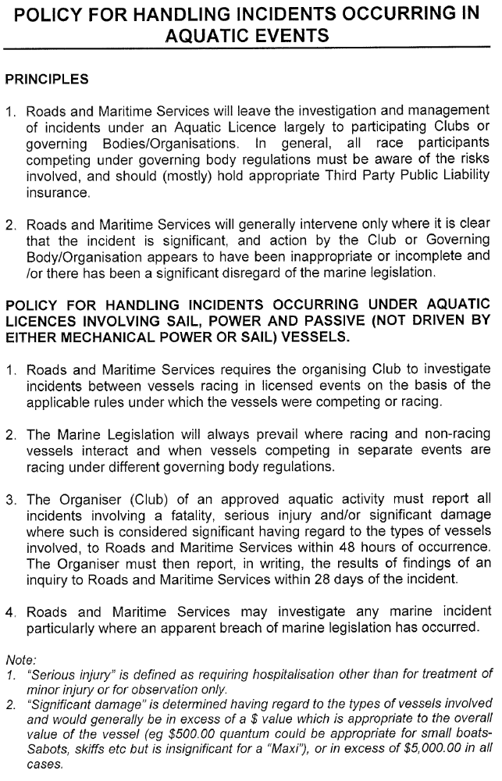
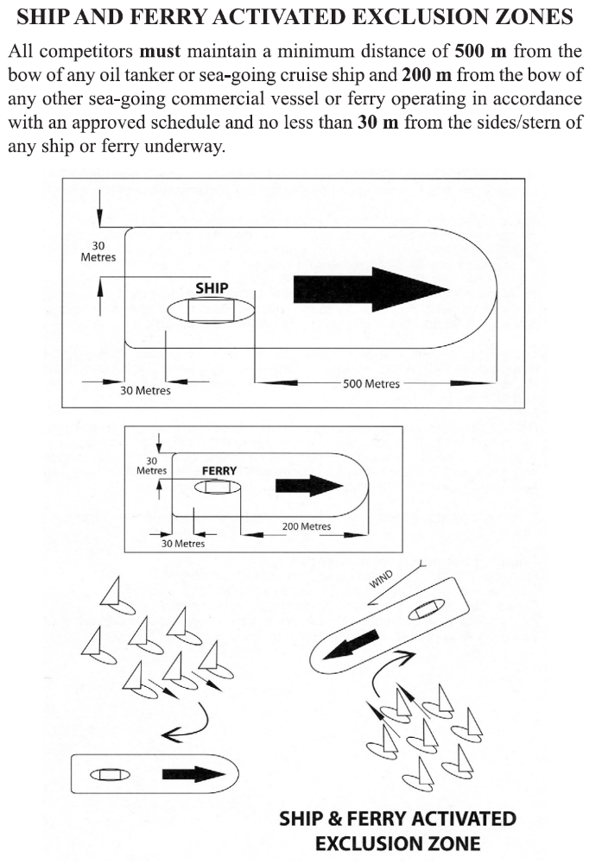

Safety and Emergency Plan for Competitors in GFS Events

Sailing is a sport which involves considerable risk. To minimise risk participants in GFS events must be familiar and comply with rules detailed in –

Racing Rules of Sailing
YA Special Regulations
Regulations for the Prevention of Collisions at Sea
Maritime Services Act
GFS Sailing Instructions
Any other Regulations (eg Commercial Shipping) that apply to boating on Sydney Harbour

Before Racing
The Racing Rules of Sailing Part 1 – Fundamental Rules apply to both you and your crew racing with the club. Please be aware and make the crew aware of the implications of Rules 1 – 5 prior to racing.

All competing yachts must have completed a current Safety Compliance Audit (Category 7) and carry the equipment identified on the audit form at all times when racing. The form must be lodged at the club.

Your crew should know how to use the Life Saving Equipment (particularly PFDs) and where this equipment is stowed on your boat. Attention is drawn to YA Special Regulations Appendix B and the need to practise man overboard procedures with your crew regularly.

Competitors should be aware of the predicted weather conditions expected during racing - Sydney Boating Weather 1900 969 955 or http://www.bom.gov.au/weather/nsw or http://www.seabreeze.com.au/graphs/nsw.asp.

The club starters will monitor VHF Channel 72 during races.

Emergencies
The club itself is UNABLE to provide emergency assistance to boats in distress. The crew of any boat in distress, or the crew of another boat witnessing a boat in distress should contact emergency services on 000, 112 (mobile) or VHF Channel 16.

Emergency Contact Details

Emergency Services 000 or VHF Ch16
Marine Area Command (Water Police - Balmain) 02 9320 7499
Marine Rescue Middle Harbour 02 9969 3270
North Sydney Police (02) 9956 3199
NSW Maritime 131 256
Volunteer Coast Guard (02) 9337 5033

Emergency Pickup Points
The following locations are some places where ambulance services may pick up a person requiring urgent medical treatment for a serious injury or illness. There are other suitable safe areas, don’t just rely on this list, familiarise yourself with these and other places you select. You must give specific details to emergency services.

Bay Street Wharf, (adjacent to the Club), Bay Street Greenwich (nearest cross street Greenwich Road).
Note: Illegal parking often makes vehicular access difficult

Northwood Wharf, Northwood Road Northwood (nearest cross street Cliff Road)
Valentia Street Wharf, Valentia Street Woolwich (nearest cross street The Point Road)
‘Woolwich Marina’ (Brokerage 9817 1020), 2a Margaret Street Woolwich (cross street Woolwich Road)
Drummoyne Wharf, Lyons Road Drummoyne (nearest cross street St Georges Crescent)
Greenwich Wharf, Mitchell Street Greenwich (nearest cross street George Street)
Noakes - Berrys Bay (9925 0306), 6 John Street McMahons Point (nearest cross street Dumbarton Street)
Mort Bay Wharf, Thames Street Balmain East (nearest cross street Darby Street)
Luna Park Wharf, Olympic Drive Milsons Point (nearest cross street Fitzroy street)
Watsons Bay Wharf, Marine Parade Watsons Bay (nearest cross street Military Road)
RSYS (9955 7171), 33 Peel Street Kirribilli (nearest cross street Carabella Street)

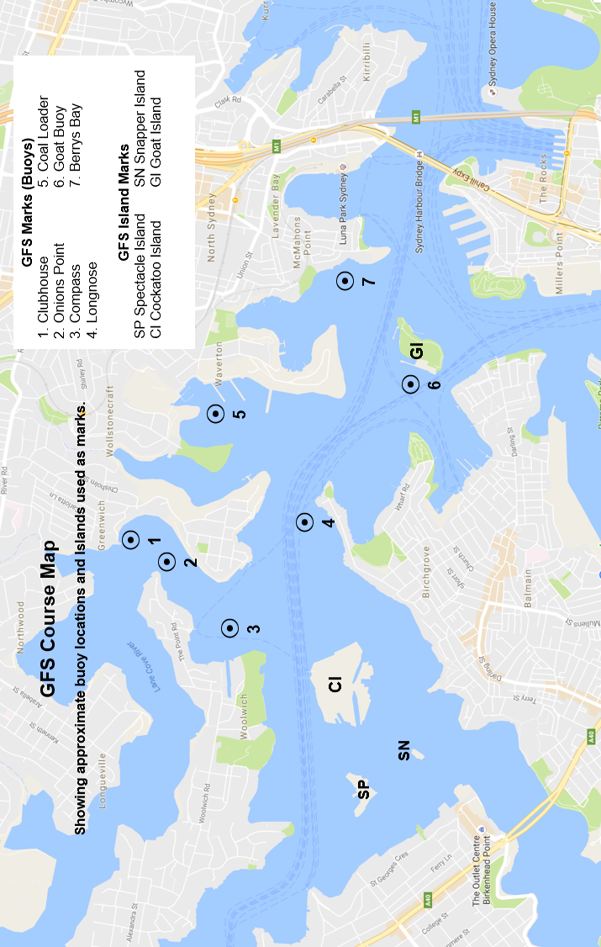
Additional Rounding Marks

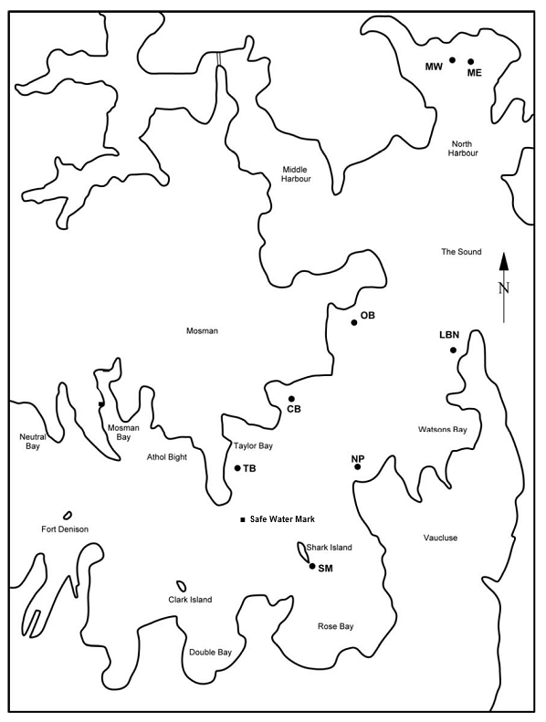

Marks and Islands used in GFS Down Harbour Courses

MW Manly West LBN Lady Bay North Fort Denison

ME Manly East NP Nielsen Park Clark Island

SM Shark Island Mark TB Taylor Bay OB Obelisk Bay

Saturday and Down Harbour Keelboat Series

The starting sequence will begin at 1315 hours for all Saturday Series. Races will start from the club launch when code flag “Q” (yellow pennant) is flown from the clubhouse flag mast, otherwise the start will be from the clubhouse. VHF 72 will give the countdown at the start and will be monitored during races.

Year | Month | Date | Event | Mick York Trophy | Details, Time and Venue
2019 | August | 10 | Working Bee |  | Clubhouse from 0900
2019 | August | 17 | Equipment Audits |  | Clubhouse 0900 - 1300
2019 | August | 24 | Equipment Audits - catch-up by appointment |  | Clubhouse
2019 | August | 31 | Spring Race 1
2019 | September | 7 | Spring Race 2
2019 | September | 14 | Joe Walsh Down Harbour Race 1 |  | Clubhouse Start
2019 | September | 21 | Spring Race 3 | MY Race 1
2019 | September | 28 | Spring Race 4
2019 | October | 2 | Skippers’ Meeting – Compulsory for all skippers – Clubhouse 1930
2019 | October | 5 | Long Weekend – No Race - Daylight Saving Commences Sunday October 6
2019 | October | 12 | Spring Race 5
2019 | October | 19 | Joe Walsh Down Harbour Race 2 |  | Clubhouse Start
2019 | October | 26 | Spring Race 6 | MY Race 2
2019 | October | 27 | Balmain Regatta – details and entries - http://www.balmainsailingclub.com/
2019 | November | 2 | Spring Race 7
2019 | November | 9 | Joe Walsh Down Harbour Race 3 |  | Clubhouse Start
2019 | November | 16 | Spring Race 8
2019 | November | 23 | Summer Race 1
2019 | November | 30 | Summer Race 2 | MY Race 3
2019 | December | 7 | Summer Race 3
2019 | December | 14 | Summer Race 4 (Sail Sydney Regatta – Sydney Harbour 12 – 15 December)
2019 | December | 21 | Joe Walsh Down Harbour Race 4 |  | Clubhouse Start
2019 | December | 28 | Christmas and New Year Break
2020 | January | 4
2020 | January | 11 | Joe Walsh Down - Harbour Race 5 |  | Clubhouse Start
2020 | January | 18 | Summer Race 5 – (MHYC Chaos Cup) | MY Race 4
2020 | January | 25 | Summer Race 6
2020 | January | 26 | 184th Australia Day Regatta – Sydney Harbour
2020 | February | 1 | Autumn Race 1 - GFS Australia Day Race
2020 | February | 8 | Joe Walsh Down Harbour Race 6
2020 | February | 15 | Autumn Race 2
2020 | February | 22 | Autumn Race 3 | MY Race 5
2020 | February | 29 | Autumn Race 4
2020 | March | 7 | Autumn Race 5 (Sydney Harbour Regatta – Sydney Harbour 7 – 8 March)
2020 | March | 14 | Joe Walsh Down Harbour Race 7 |  | Clubhouse Start
2020 | March | 21 | Autumn Race 6
2020 | March | 28 | Autumn Race 7 | MY Race 6
2020 | April | 4 | Autumn Race 8 -
2020 | April | 5 | Daylight Saving ends
2020 | April | 11 | Easter – No Race
2020 | April | 18 | Joe Walsh Down Harbour Race 8 |  | Clubhouse Start

Twilight Series

The start sequence will commence at 1740 hours. Coloured boards indicate the course to be sailed by each division. The course number for Red Division will be displayed on a red board, the course for Green Division, Yellow Division, White Division and Blue Division on a white board and the course for Black Division will be on a black board. The start will be from the Clubhouse. VHF 72 will give the countdown at the start and will be monitored during races.

Year | Month | Date | Event | Other Information
2019 | August | 10 | Working Bee | Clubhouse from 0900
2019 | September | 21 | Equipment Audits | 0900 - 1200
2019 | September | 29 | Equipment Audits | 0900 - 1400
2019 | October | 2 | Skippers’ Meeting – Compulsory for all skippers – Clubhouse 1930
2019 | October | 5 | Equipment Audits Final Catch-up | 0900 – 1600
2019 | October | 6 | Daylight Saving Commences
2019 | October | 9 | Spring Race 1 | BBQ and Bar Open
2019 | October | 16 | Spring Race 2 | BBQ and Bar Open
2019 | October | 23 | Spring Race 3 | BBQ and Bar Open
2019 | October | 27 | Balmain Regatta – details and entries to Balmain Sailing Club
2019 | October | 30 | Spring Race 4 | BBQ and Bar Open
2019 | November | 6 | Spring Race 5 | BBQ and Bar Open
2019 | November | 13 | Spring Race 6 | BBQ and Bar Open
2019 | November | 20 | Spring Race 7 | BBQ and Bar Open
2019 | November | 27 | Spring Race 8 | BBQ and Bar Open
2019 | December | 4 | Spring Race 9 and YOTS @ GFS | BBQ and Bar Open
2019 | December | 11 | Summer Race 1 – Handicap start | BBQ and Bar Open
2019 | December | 18 | Summer Race 2 – Handicap start | BBQ and Bar Open
2019 | December | 25 | Christmas Break – New Year break
2020 | January | 1 | Christmas Break – New Year break
2020 | January | 8 | Summer Race 3 – Handicap start | BBQ and Bar Open
2020 | January | 15 | Summer Race 4 – Handicap start | BBQ and Bar Open
2020 | January | 22 | Summer Race 5 – Handicap start | BBQ and Bar Open
2020 | January | 26 | 184th Australia Day Regatta – Sydney Harbour
2020 | January | 29 | Summer Race 6 – GFS Aus Day Regatta Race  – Handicap start | BBQ and Bar Open
2020 | February | 5 | Autumn Race 1 | BBQ and Bar Open
2020 | February | 12 | Autumn Race 2 | BBQ and Bar Open
2020 | February | 19 | Autumn Race 3 | BBQ and Bar Open
2020 | February | 26 | Autumn Race 4 | BBQ and Bar Open
2020 | March | 4 | Autumn Race 5 | BBQ and Bar Open
2020 | March | 11 | Autumn Race 6 | BBQ and Bar Open
2020 | March | 18 | Autumn Race 7 | BBQ and Bar Open
2020 | March | 25 | Autumn Race 8 | BBQ and Bar Open
2020 | April | 1 | Autumn Race 9 | BBQ and Bar Open
2020 | April | 5 | Daylight Saving Ends

.

All Yachts registered for the Saturday and Twilight Series are eligible to enter the Mick York Trophy Series and Saturday Down Harbour and Mick York Series. The starting sequence will begin at 1315 hours for all Saturday Series races

Mick York Trophy Races

Year | Month | Date | Event
2019 | September | 21 | Mick York Trophy Series Race 1
2019 | October | 26 | Mick York Trophy Series Race 2
2019 | November | 30 | Mick York Trophy Series Race 3
2020 | January | 18 | Mick York Trophy Series Race 4
2020 | February | 22 | Mick York Trophy Series Race 5
2020 | March | 28 | Mick York Trophy Series Race 6

Joe Walsh Rigging Down Harbour Series

Year | Month | Date | Event
2019 | September | 14 | Joe Walsh Down Harbour Race 1
2019 | October | 19 | Joe Walsh Down Harbour Race 2
2019 | November | 9 | Joe Walsh Down Harbour Race 3
2019 | December | 21 | Joe Walsh Down Harbour Race 4
2020 | January | 11 | Joe Walsh Down Harbour Race 5
2020 | February | 8 | Joe Walsh Down Harbour Race 6
2020 | March | 14 | Joe Walsh Down Harbour Race 7
2020 | April | 18 | Joe Walsh Down Harbour Race 8

The West Harbour Winter Series is run as a combined event with Balmain Sailing Club, Drummoyne Sailing Club and Parramatta River Sailing Club. Entry is open to all GFS yachts at no additional cost.

West Harbour Winter Series, 2020

Year | Month | Date | Event | Other Information
2020 | May | 3 | WH Winter Series Race 1 | Dates for the combined Balmain Sailing  Club, Drummoyne Sailing Club and  Greenwich Flying Squadron West Harbour Winter Series are subject to change.
2020 | May | 17 | WH Winter Series Race 2
2020 | May | 31 | WH Winter Series Race 3
2020 | June | 7 | WH Winter Series Race 4
2020 | June | 21 | WH Winter Series Race 5
2020 | July | 5 | WH Winter Series Race 6
2020 | July | 19 | WH Winter Series Race 7

